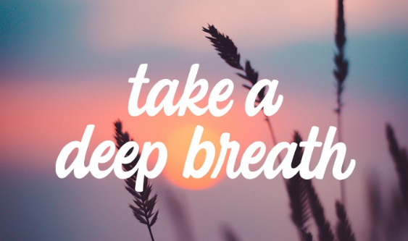
Trainee top tips – Breathing exercises

Those things that happen when you are stressed, such as increased heart rate, fast breathing, and high blood pressure, all decrease as you breathe deeply to relax. The way you breathe affects your whole body. Breathing exercises are a good way to relax, reduce tension, and relieve stress. These are different methods you might use.

Breathing exercise for stress
This calming breathing technique for stress, anxiety and panic takes just a few minutes and can be done anywhere.
You will get the most benefit if you do it regularly, as part of your daily routine.
You can do it standing up, sitting in a chair that supports your back, or lying on a bed or yoga mat on the floor.
Make yourself as comfortable as you can. If you can, loosen any clothes that restrict your breathing.
If you're lying down, place your arms a little bit away from your sides, with the palms up. Let your legs be straight or bend your knees so your feet are flat on the floor.
If you're sitting, place your arms on the chair arms.
If you're sitting or standing, place both feet flat on the ground. Whatever position you're in, place your feet roughly hip-width apart.
- Let your breath flow as deep down into your belly as is comfortable, without forcing it.
- Try breathing in through your nose and out through your mouth.
- Breathe in gently and regularly. Some people find it helpful to count steadily from 1 to 5. You may not be able to reach 5 at first.
- Then, without pausing or holding your breath, let it flow out gently, counting from 1 to 5 again, if you find this helpful.
- Keep doing this for 3 to 5 minutes.

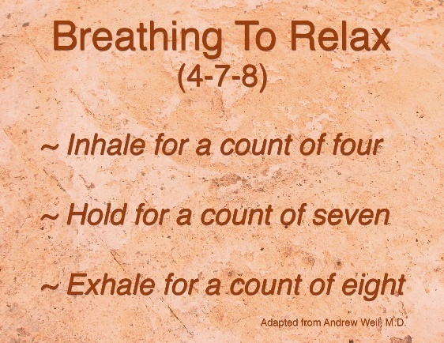
4:7:8 breathing technique

To watch a video of this technique, follow this link

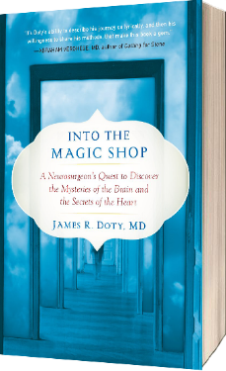

Into the magic shop
These mindfulness relaxation exercises, based on this book, can be found here.

Breathing Exercises That Can Help You Relax in 10 Minutes or Less
Overworked, sleep-deprived, and stressed out? Same. But luckily, there are plenty of ways to regain a sense of calm. All you need is a pair of healthy lungs, your breath, and 10 minutes of “me” time. It’s called controlled breathing. The link to these 6 exercises is here.

