I have handled my Dyslexia and Arthritis.- : Liv (2019 Secondary Trainee)
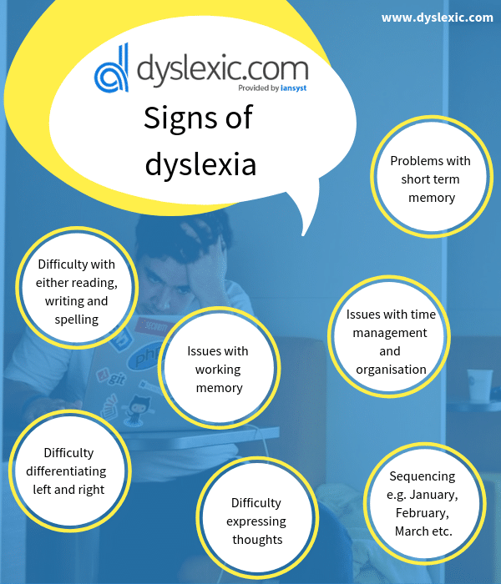
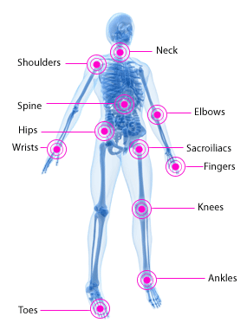
I was terrified about starting teaching even without thinking about how my Dyslexia and Arthritis would factor into such a high pressure environment. Especially as the latter wasn’t diagnosed until I was 20. The thought of having to start a new job, in a field I had very little experience in as well as knowing these were both something I would have to discuss with my new employer was stressful to say the least. So, here are a few tips I have found useful and I hope they can be of use to you.

- Be Vocal: Tell. Your. School. It sounds like a terrifying thing to do, walk up to a new employer and give them a list of your medical issues. But having the school aware from Day one makes them so supportive and willing to help as they know and can plan for any potential issues before they become one. Keeping the school as part of the conversation about your health I have found so beneficial, especially when I needed to step out of a parent’s evening or two in the winter. Even something as little as being able to sit down as you teach is important as they can communicate that to members of staff who might be coming to observe you. The schools are so pleased to have you as part of their team they will be so willing to do anything they can to support you in any way they can with whatever your condition might require.

- Drawing a line: This is so important I wanted to put it at joint number 1. Without meaning to scare you teaching is a job that never feels done; there seems to always be something more you could be doing, a final book that could be marked, that extra tweak to a lesson plan, a point for CPD you could explore and most of the time it means you can still be up at 1am if you don’t draw a line. No one else is going to tell you to stop working so it’s so important that you put your own restrictions in place. As a rule, I never work past 7 during the week, not at all on a Friday night, or a Saturday. No matter what comes up at school this is the time I protect and sometimes that means some things don’t get done, but no deadline is ever more important than your health.
.

- Use the people around you: My in school mentor, fellow trainees and my department have been my biggest support network in school. As well as being able to answer any questions you have (and they will answer any question- no matter how silly it might sound to you) they also helped me with many things I hadn’t even considered before the job. My mentor would proof- read all my lessons for any SPAG errors; members of my department would tell me to go home when I was there too late. In winter they would even carry sets of books down to my car for me (I have now invested in a great trolly for this reason) They have all been through the exact same emotions you will be going through and they only want to help you, so let them.

- Be Honest with the Students: This is one of my favourites. I had no intention of coming out and declaring this in my first lesson, but as and when it was commented on, I was honest with the students about my conditions. There was one particular student who was behaviourally challenging who often used their dyslexia as an excuse not to work in my lessons, so when I told them I understood and explained my own condition and my struggles in English, it created a much better relationship with that student. It also then side-tracked my Year 10’s for a good 15 minutes as they asked a lot of questions, but it helps them to see you as a Human. The lower years also liked checking my spelling in dictionaries and if they saw me sat down for the lesson, they would offer to do everything for me. It creates a great message for the students as well: If I can do it, then so can you.

- Organise, Organise, Organise! My dyslexia means I often struggle to prioritize the right thing and lose track of deadlines, but this is just vital if you aren’t going to drown in paperwork and deadlines. You simply won't be able to keep on top of books, lesson planning and essay writing without some outside help- dyslexic or not. Invest in a really good Teacher Planner (Not a trainee one, you won’t have the space you need!) I have also found having a separate year calendar with all the deadlines on helps me to see what needs to be prioritised as well as a daily To Do list, so I know what needs to get done each day. Organisation is just about finding a system that works for you, so these might not all help, but getting organised will make your TeachFirst days much easier (and will even allow you to buy early train tickets for your conference days!)

These are all taken from my personal experience and I really hope some of these will be of use to you. It has been a hard but rewarding year and these have really helped me cope with my conditions on top of my job. Some days are still hard and a struggle to keep everything going, especially when I am in a lot of pain, but one of the joys of this job is that every day is different so you will always end up back on your feet (in my case literally!)

