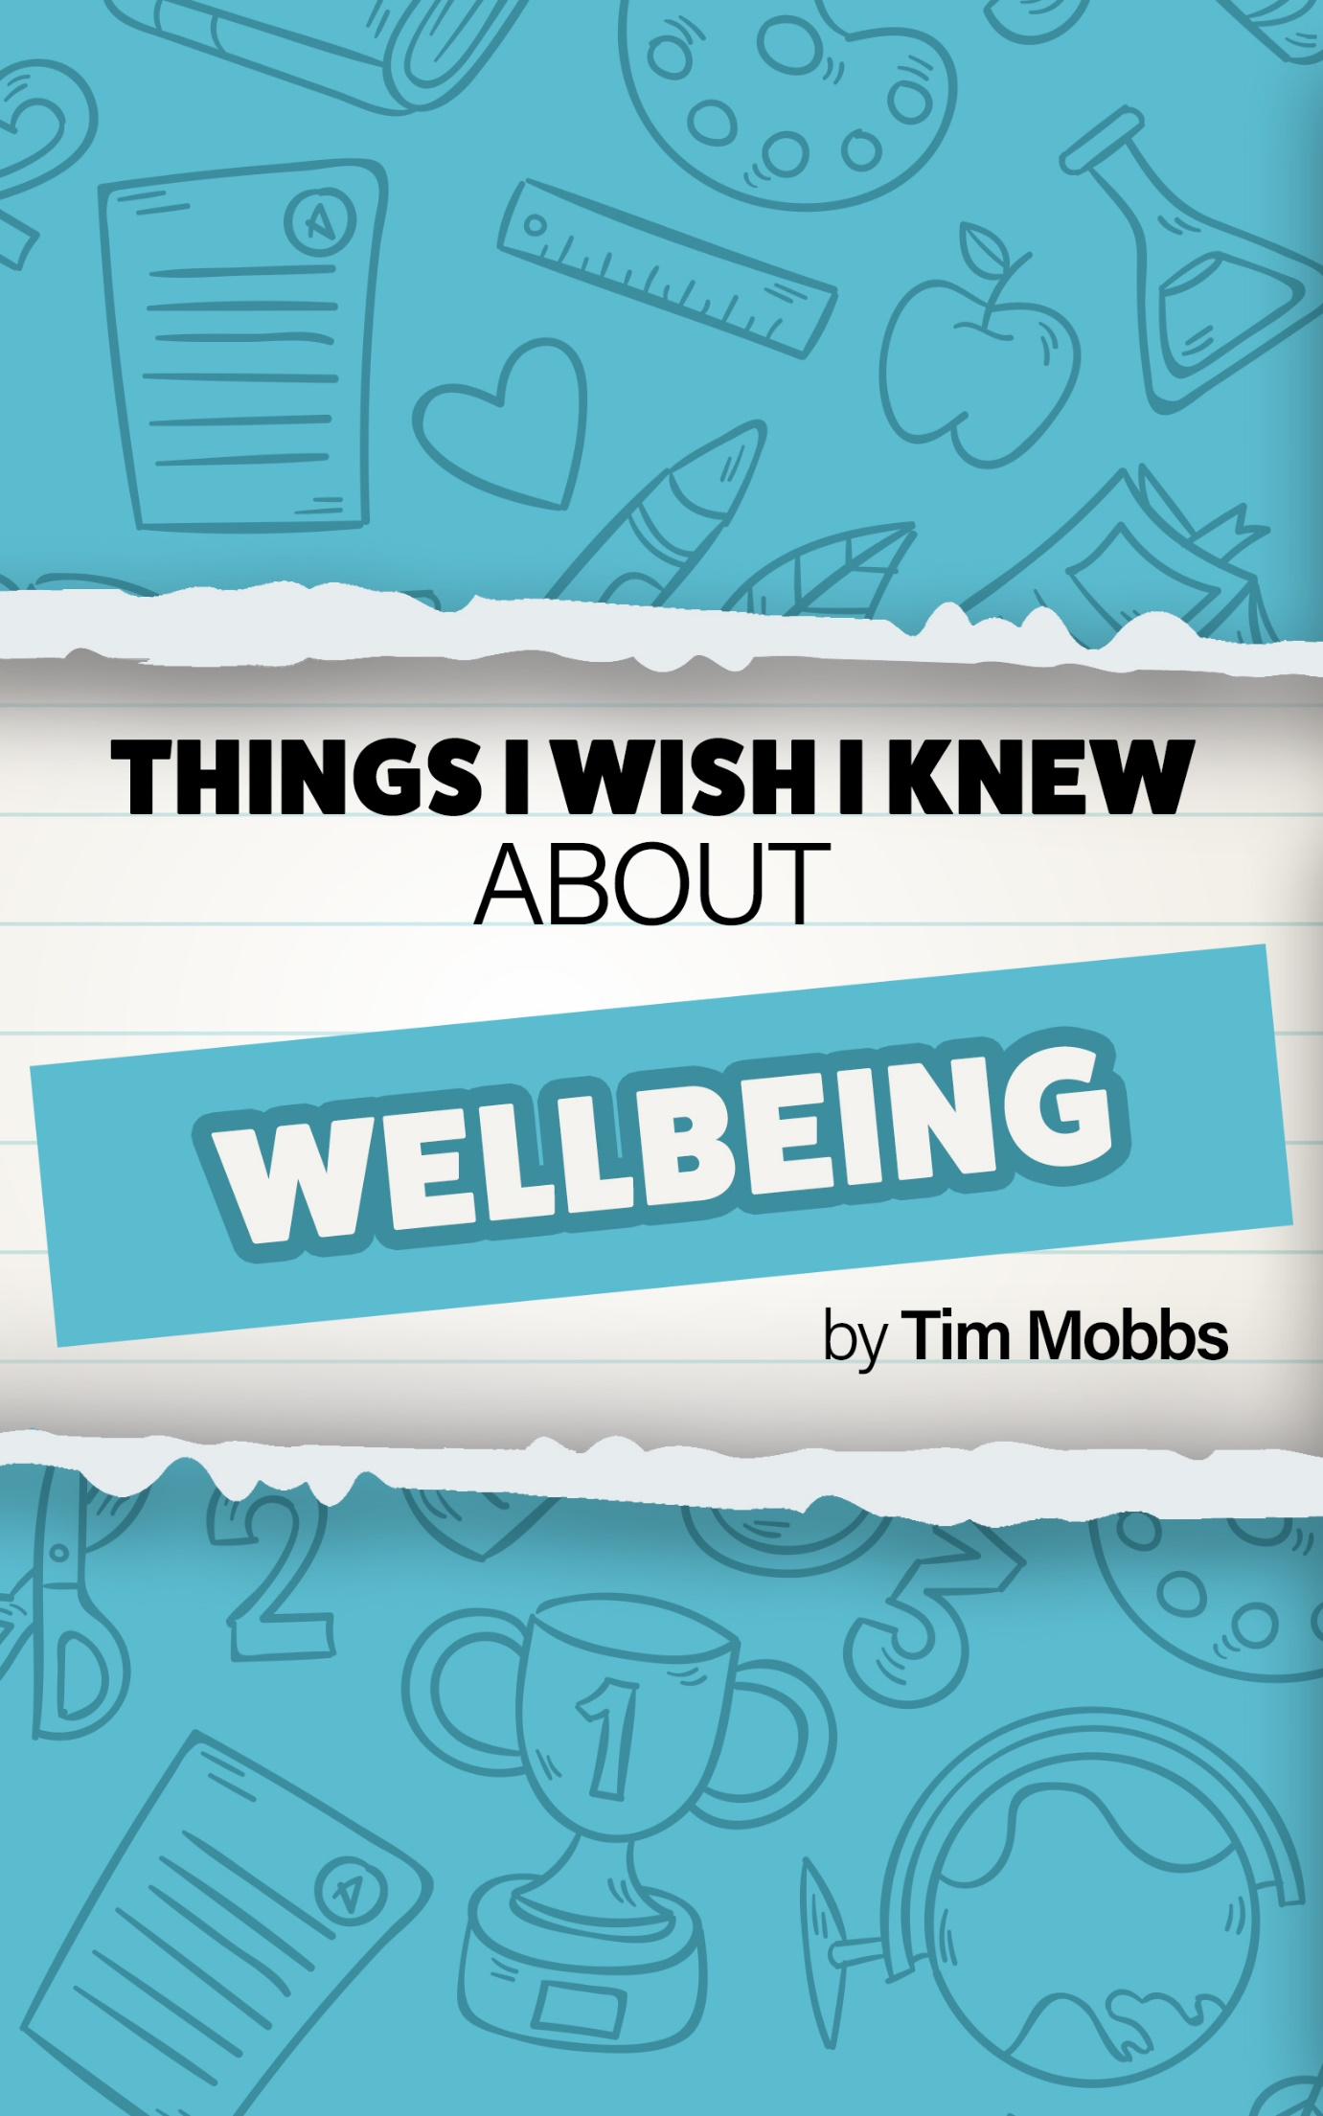Things I wish I knew…
Tim Mobbs
I give permission for this to be shared and copied freely (please reference).
Introduction
Wellbeing is a buzz word in education at the moment and it absolutely should be! I think the teaching profession has created a culture where it is almost a badge of honour to announce publicly that “Here I am marking at midnight again.” Or “Here’s a picture of my weekend. (insert picture of a pile of books; a laptop with planning open; a laminator proudly churning out resources). My question is – why? Why are we championing our workload and celebrating the worst parts of our wonderful profession?
It is far too easy as a young teacher to see this and completely buy into the culture of work until you drop… and I did for years. My first school laptop was a Toshiba… after my first year of teaching my wife called me Mr Toshiba head because that is all she had seen for a year. I cost myself family time, friends, hobbies and time for myself. This is unacceptable for any profession and it is a major reason for the current retention/recruitment crisis in education.
Of course, there are wider systemic issues beyond an individual teacher’s control – school leaders have an enormous and essential role to play in this through sensible school policy making and expectations (many are doing it already). However, I believe if we open our eyes and change our mindset then we can change the work until we drop culture and win back our weekends.
The following is an extract from my book “Things I wish I knew before becoming a teacher.” I hope it helps you focus on yourself and how to take ownership of your wellbeing.

Wellbeing

You will always have more work you could do.
You must give yourself permission to say enough is enough. You could work every second you are awake and still have work to do. You will dream about work – some of my greatest lessons have been based on school dreams! It is important to set yourself limits and know when to stop. Prioritise and ‘don’t sweat the small stuff’.

Teaching feels like you are on a treadmill – that’s why you are so tired all the time.
There is no end to your ‘to do list’. Your job is never complete because there is always something else to do. You go on and on and on planning, delivering, marking, reflecting, planning, delivering, marking reflecting and so on and on. You need to rest and sleep when you can. Although many in teaching seem to have the self-harm mindset of work until you drop, that is not the way. If you are too tired then you can’t be your best self and it is your best self that your pupils need and deserve. It is absolutely fine not to reach the end of your to do list… there is always tomorrow.

Don’t be scared/too proud to ask for help.
As a student teacher I went through periods where I really struggled. I could not seem to make sense of things that seemed to be easy to other teachers. I told a colleague that I was struggling and got the response of, “That’s teaching.” Well, that isn’t teaching at all! Would we tell a struggling pupil that “That’s school.”? No, we wouldn’t. My colleague failed me here by not giving or guiding me towards support.
You will find things hard. You must ask for help whether from a mentor, a tutor, another student, a colleague, a leader in school… someone! Do not struggle alone because asking for help isn’t a weakness, it is a strength. To struggle on alone will likely end in stress, feeling like a failure and ultimately a desire to leave the classroom. If yourself in a position where you feel you have no support then please contact me and I will help in any way I can.

Plan “easy” lessons for yourself every now and then.
Plan lessons into your week where there is little or no need for you to stand and talk to the class. Facilitate, set them off and allow them the freedom to work independently. Take the time this allows you to carry out interventions, mark books, give verbal feedback and any other jobs you feel that you don’t have time to do. This is allowed… it is part of the job you are paid to do…
In my early career I felt like this was cheating. I wondered how more experienced colleagues could arrive later and go home far earlier than me and seem to achieve better results in the classroom. Timetable management. Use the time you are in school as efficiently as possible.

Work smarter not harder.
Find ways of saving yourself time. Working harder is not as effective as working smarter. For example, when you collect in children’s books, ask them to hand them in open on the page they have been working on. If you save 10 seconds a book in a class of 30 then that is 5 minutes extra where you would have been flicking through pages. Train children to do jobs in the classroom like organise resources, tidy the reading corner, collect and hand out books. Every minute you save yourself is an extra minute you can dedicate to other jobs or, ideally, your own wellbeing.

Only be concerned about the things you can control – don’t waste energy on things you can’t.
There are many things in education that you have no control over but many of these things seem to cause teachers the most stress. For example, OFSTED… “The Call” is something that is talked about constantly. For the first few years of my career I was constantly concerned about it (and had it every year). I wasted so much energy and brain time on thinking about it but I could not control when it would happen. Instead, I should have concentrated on making sure my day to day practice was as good as possible for the benefit of my children. I can control (on the whole) what happens in my classroom. I can control the standards and expectations I accept. I can control the quality of work I am willing to accept from my pupils. I can control planning engaging and interesting learning sequences. I can control my positive persona. I can control eating breakfast and lunch. I can control many things, too many things to worry about the things I can’t control.
If you take care of everything that is under your control and do it really well then anything you can’t control will never have a negative effect on you.

Take at least one day off at the weekend.
I believe you should take both days off at the weekend, however, it is very rare that I am able to do this. As a student and NQT, I worked 7 days a week and then most of half terms and end of term breaks. I felt I had to. Before I began teaching, I played semi-professional rugby on a Saturday, trained twice a week and went to the gym. I could not sustain this as a student teacher and I threw my entire existence into being a teacher. I stopped everything, and I regret it. I piled on weight through becoming sedentary, drinking more and eating when I could. You need to make sure that you are working to enable you to have a life and not living to work. What is the point of slogging your guts out if you do not step back and take some time to enjoy your life. Promise yourself to have at least one day off a week; it will make a dramatic difference to your wellbeing.

Plan things to look forward to.
I struggle to focus on more than one thing at once – I always have. For years, I was so focussed on teaching that a holiday would arrive and I would have no plans at all and they would pass by so quickly and then I would be back on the teaching treadmill.
The best holidays are those that are full of the things that you can’t do during term time. Make the most of the holidays, they are a much needed (and one of the few) perks of being a teacher. The hard days and weeks are easier to manage when you know that in a few weeks you have amazing adventures to look forward to.

On short days where you arrive and leave in the dark – get outside in the light at some point.
During winter, you travel to work in the dark and generally leave after dark. If you don’t leave your classroom all day, then it is realistic that you won’t go outside in the daylight at all. It can make such a significant difference if you get out into the fresh air and light because you could end up not seeing light all week. Make time to get outside.

Exercise as much as possible.
I remember a lecture about wellbeing during my training. The speaker said, “Even though it is really hard, I try to get to the gym or go for a run every day.” I thought that would be no problem as I had an active lifestyle… how wrong I was. Entering the classroom consumed every waking moment and my active lifestyle disappeared – for many years. It is natural to become focussed on your own development as a teacher and the progress of your classes, but you are a more effective professional if you spend time maintaining your health. Get outside, go for a walk, go for a run, go to the gym … do something. It might seem like wasted time, but it really isn’t.

Leave early once a week.
Your school caretaker should not have to ask you to pack up and leave every day, but I got into a routine where this was the case. I had several Teach First trainee colleagues who were locked in their buildings because the caretaker missed them on their final rounds. Don’t let this happen to you. Plan an evening a week where you leave school by four o’clock. Plan a low/no preparation lesson for the following day and enjoy your evening of freedom. Refresh, reset and recharge. A few hours away from the grind of teaching will do wonders for your wellbeing.

You will lose your voice.
I generally lose my voice at some point in Autumn term. I start with a slightly sore throat which then gets worse and worse. The ironic thing is that when my voice does go completely the pain seems to go too… I just can’t speak. I am rubbish at treating myself and always try to push through the initial sore throat. Your voice is your job… look after it. Don’t push through and carry on as normal. Plan lessons where you do not have to do much talking. Speak gently and quietly. Make sure you medicate and consume any wonderful family recipes you may have… and if you can, speak to your leadership and explain your situation – if they are sensible then they will help you manage because if you lose your voice they will have to replace you for a number of days. Look after yourself.

Take a break from school work during the holidays.
I used to look forward to holidays as it gave me a chance to catch up on all the work I had not managed to do and I always intended to get loads done so I was ahead for the following term. I also gave myself the treat of saving my academic assignments for these teaching breaks. Then I would decide to have a couple of days off and feel guilty the whole time.
If you can get to the point of doing no work in your holidays then you are better than me. I now plan a day (sometimes a day and a half) that I dedicate to work. I haven’t worked out whether this is better at the very start or the very end of the holidays but either way I plan it, speak to my family and we all know that is when I will be working. It means I have several consecutive days where I do not do anything school related… this is essential because by the end of each half term I am unbelievably tired. I find my brain can’t hold information and even the simplest task becomes insanely difficult. You must recharge and relax or you will burnout. You must step off the treadmill… take a well-deserved break – you’ve earnt it.

Mark in lessons as much as possible.
Written marking is a much-debated topic in education and schools have a variety of marking policies. Sadly, there are many who treat marking as a way of showing progress to external visitors (OFSTED, school improvement officers, consultants etc) and not for the benefit of the children. Written marking takes a long time and often has no impact on learning. As a student and NQT my school’s policy required the use of green and pink highlighters for different areas and three written comments in the form of two stars and a wish… for every… single… piece… of… work! I had no idea how to manage this (and still don’t know if anyone could or did). I had 36 children in my class, they had 3 books each that was 108 books to mark. If I managed to take 3 minutes per book (an impossible task) then this meant marking would take 324 minutes per night… over 5 hours per night… WHAT!? There were ways of avoiding this, like staggering which books I got the children to do written work in each day but when one set of books takes well over an hour to mark the task is ridiculous.
My pivotal moment came when following a conversation of Twitter about teachers’ favourite soundtracks to mark to. Classical, musicals, pop, country and many other genres were mentioned until a single post exploded into my life… “I mark to the sound of children working around me.” The biggest impact you can have is marking with children and giving them “live and immediate” feedback. Writing a comment, as you drink wine and watch tv has little or no effect on their learning. You can drown in written marking, do not let this happen.

More thoughts and advice from the wider world
Since publishing ‘The things I wish I knew before becoming a teacher’, I have spoken to many leaders within education and beyond about wellbeing and the things that can have a positive influence on teams and individuals. I have tried to distil the comments and suggestions here and offer solutions for some issues that were raised.
World outside the classroom
There is a whole wide beautiful world outside of your classroom and your school. A job, such as teaching, can become all-consuming to the point that everything you do is tainted by an underlying focus on it. It is essential that you dis-engage fully during your leisure time otherwise it really isn’t recharging leisure time at all.
We are preparing future generations to be outstanding members of our society and the wider world. It is part of our job to model what this looks like. Spend time with people who make you happy. Visit places you have always dreamed of. Attend events (not work related). And then share these experiences with your children. You will feel amazing in yourself and you are modelling how to be a global citizen at the same time. (Even when you do all these things for yourself, somehow your work still gets done and the school does not fall down around your ears!).
The wider impact of your actions
Personal wellbeing is of course a major priority; however, you may well be affected by other people’s personality, attitude or stress. This is a really tricky situation because it can be hard to avoid. There are a few things to consider here: is it worth letting someone else affect you in a negative way? What is causing them to act the way they are? Is there something you could do to help them improve their wellbeing and in turn their mood? Perhaps there is but this is not always the case. If you can’t help, then my advice is to give these people a wide berth and focus on the positive aspects of your work life.
On the other hand, if you know that you are the person who can moan, gossip and bring a negative attitude to situations then please remember it is important to manage yourself, so you are positive influence on those around you – please don’t let your stress, gripes or attitude bring those around you down. It is a conscious decision about how you present yourself to your team. I am by no means saying don’t speak to colleagues if you are finding things hard, but I am saying please think about where, when and how you do this.
Gossip
This can be a major factor in negative wellbeing in schools and professions beyond teaching. It can be tempting to become involved with this and listen to / pass on “juicy” information – it is unprofessional and has wider and lasting consequences. It is something to avoid at all costs. As a professional you have a responsibility to address situations in a certain way, whether this means keeping something to yourself or addressing something privately with a colleague. It can affect other people’s wellbeing if they know you have been involved in “talking about them” behind their backs, but it can also affect your own wellbeing if you damage relationships with colleagues and become known as a gossip.
Lesson observations
These two words can strike fear into the heart of a teacher and have a negative effect on wellbeing. Many hours can be spent preparing the ‘perfect’ show lesson and worrying about an impending visit. Sleep can be lost and it can begin a downward spiral.
Creating an ethos of development and support around observations is the responsibility of senior leaders. When this happens, both staff and pupils thrive. Unfortunately, this is not always the case and we as individuals must bring our own positive mindset to the process.
Accepting that observations are part of the profession is the first step. Second, is accepting that feedback is valuable even if you do not necessarily agree. It is part of being a professional to want to improve and there is evidence that observation and developmental meetings are hugely beneficial so buying into the process and accepting it with an open door is massive. Great advice for observations are to just do what you normally do. First of all, if you change massively then what can actually happen is that the children get confused and learning stalls. Also, the observer should see that the lesson does not work in a sequence of learning. Finally, if you are having to change what you normally do so significantly then should you perhaps think about your normal practice?
Just treat an observation day like any other day. Frame it as an opportunity to ‘show off’ and share your great practice. Seize the opportunity to receive feedback from an experienced colleague. Ask questions. Drive your development.

Leaders – setting culture and example
Although it is the individual’s responsibility to manage their own wellbeing, this becomes so much easier when the leadership enforces it as a priority. A wellbeing led culture is something that must be cultivated, messaged properly and genuinely initiated. It is too easy to just say “look after your wellbeing”. Leaders must set, lead and live the culture they want for their teams. Some fantastic initiatives are in action around the country and they are not hard to replicate (minimal cost, enormous impact on wellbeing).
- Day/days off in lieu for staff going above and beyond (like residentials)
- Wellbeing days (a free day during term time instead of training day)
- Not holding meetings for meeting’s sake
- Not making staff carry out ‘wellbeing’ activities before or after school: just letting professionals make their own choices and go home.
- Allowing PPA to be taken at home.
- Making it clear that staff can have time off to attend family events (and not be penalised at all for it).
- Taking the time to genuinely say thank you.
- Closing the school early one night a week and encouraging staff to go home early.
- Sensible and fair appraisal (professional dialogue).
- And a personal favourite of mine… Cake (and/or fruit).
- Sensible, manageable and evidence based marking policies.
- Minimising paperwork – including planning! There is absolutely no justification for planning to be handed in on a Monday morning or pinned up on the wall. It is a waste of valuable time.

Final thoughts…
So, my plea is for you to take control of what you can control and make wellbeing a high priority. I know that this seems impossible at times, but it is so important! Say no to late nights and long weekends of work and instead have late nights and long weekends full of all the things you love to do. We can do this if enough of us buy into the change so next time you see a picture of a pile of books to mark – challenge the person and ask them - why?

If you have found this useful then you will also like my full book, written with busy teachers in mind, “The things I wish I knew before becoming a teacher” available as an e-book and paperback here: https://amzn.to/2Q4WGSE
It includes:
Settling in to school
Wellbeing
Home Life
Wider School Life
Behaviour Management
Classroom Teaching
Personal Development
Relationships
Teaching Practice
The World of Education

This is what people are saying with 5* reviews:
“This is hands down the best purchase I have made in preparation for my PGCE. It is split up into sections about different areas of not just teaching but all areas of school life. It should be on every PGCE reading list. Definitely one to keep with me for years to come.” A. Morris

“A must read for all entering teacher training!
This book is split into useful sections detailing advice for all areas of the life of a teacher both inside and outside the classroom. I know I will be able to refer back to the tips and tricks detailed in this book throughout my PGCE and subsequent years of teaching and would recommend that all those entering the teaching profession grab a copy to help them work smarter from day one in the classroom.” S. Naylor

“Excellent read, for both new teachers and experienced teachers! Refreshes your thinking about teaching and reminds you what a fantastic job it is to do!!!” F. Beckwith

“Great and easy to read.” Amazon customer

“A very useful and practical read:
I’m into my fourth week of teaching and have found this book very useful, both in the build up to starting and from then until now.” Marsh

