Information for Previously Trained Mentors on the ECTP 2025

When you log in to Bright space, you may be presented with a Y/N question that asks for your previous experience of either ITT or ECF based mentor training.
If you answer Yes to this question, then you will need to complete a Training Needs Analysis via the ECTP for Trained Mentors tile- see below image:


You will then need to click into the WELCOME SESSION- see below image
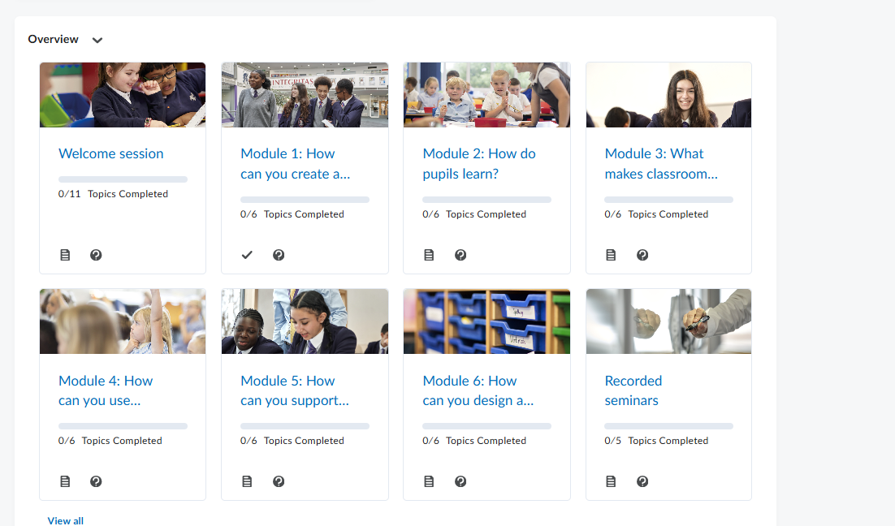

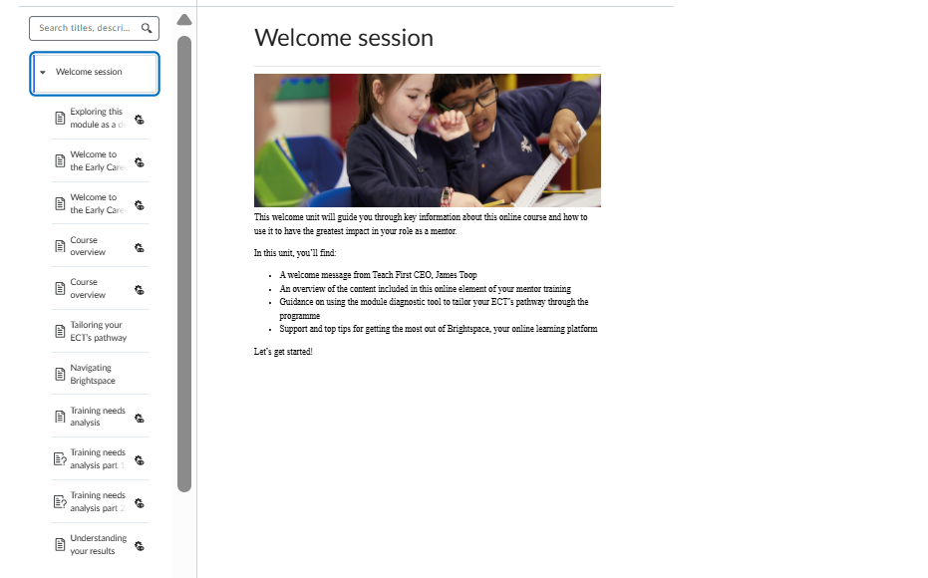
Within the welcome section, if you scroll down, you will see a Training Needs Analysis on the left-hand side. Please select this and complete it (see below image):

This analysis, when completed, highlights which aspects of the mentor programme you need to complete. It will show you a suggested pathway for each module and seminar for the year ahead and will suggest ‘optional’ or ‘strongly recommended’ for each.
Please get in touch with NTSH if you encounter any difficulties completing this.

